Nicole Vogel
SEBK 725 Reading Judges with Teens
May 7, 2018
Using Samson with Teens: An exegetical look at Judges 13-16

The story of Samson is one of the more well-known narratives from Judges. There have been movies and plays based on this narrative. Samson is like a super-human with exorbitant strength whose story sound like one you might find in a Marvel comic book, not the Bible. His story is full of violence, sex, betrayal, and death by suicide, which is great for action movies but is often avoided for Biblical studies. Yet these difficult passages like Samson’s are often insightful and useful for facing the violence, sex, and betrayals that occur in modern reality. In our modern reality the frequency of violent mass shootings that end in death by suicide is increasing. Samson’s story can be used to face the issue of violent acts of murder that end in suicide with any group, but especially with teens who seemed to be very impacted by these violent acts. It can also be used to understand the psychological process that leads one to choose death by suicide. Samson’s story displays parallels to modern mass shootings and deaths by suicide that are increasing at an alarming rate. Those parallels can be used with teens seeking a different outcome, or who identify with Samson’s suffering psychological journey.
The story of Samson really begins before his birth in Judges, chapter thirteen. It begins by revealing that his birth was a miracle because his mother was a barren woman. Before she gave birth, she was told by an angel of the Lord that he would be designated as a nazarite. The Hebrew Bible informs what a nazirite vow entails in Numbers 6. Numbers reveals that it is a vow of one’s choosing to “separate themselves to the Lord” They separated by refraining from wine and strong drink, grapes or any grape product, razors to cut the hair on their head, and being near dead bodies even if it is their families funeral.
This passage from Numbers also explains that the vow is taken for a specified amount of time at which when that time is completed a ritual is performed and one is absolved from the refrains necessary during the time as a nazirite. However, Samson was designated as a nazirite “from birth to the day of his death.” This means Samson was not only never given the choice to be a nazirite which included a life with strict requirements, but he also was forced to serve as one his entire life. One must wonder what kind of effects this might have had on his psyche. This designation of nazirite seemingly has no parallels to a modern context. However, if we think about the parent(s) who choose a life path for their child to live into from birth, such as the owner of the family business or like the parent(s) who push(es) their child into activities to vicariously live out their own unmet desires instead of allowing the child autonomy to choose for themselves the parallels are revealed.
Given this designation from birth to death, it should be no surprise that he rebels against his vows and acts like a spoiled child demanding his parents get a wife for him among the Philistines who were harshly oppressing the Israelites his whole life. He himself was probably a victim of this oppression at some point, but still choses to obtain a wife from this oppressive non-Israelite culture contending the Israelite culture law. Again, we can parallel Samson’s narrative to modern teens who rebel against the constant pressure to be someone their parents desired not who they yearned to be even if it means committing an act that the wider culture views negatively.
Samson’s actions then begin to reveal his potential to violence. On the way to meet and marry his Philistine wife he encounters a lion and he “tore the lion apart barehanded as one might tear apart a kid.” (kid meaning young goat) This verse goes on to explain that he did not share his violent and amazing strength with his parents and continued on with his visit to Timnah. Samson likely kept this miraculous encounter from his parents to avoid the probable reminder of his nazirite status which he rejected. Samson’s refusal to tell his parents also displays his propensity towards violence. This act of violence in which Samson chooses to keep from his parents may have been a warning sign of his future violent end. A warning sign for modern mass school shooters is “an act of violence that appears unrelated to any targeted-violence pathway warning behavior committed for the first time.” This first violent action by Samson and his desire to hide it from his parents reveals warning signs of troubled mental stability and poor coping mechanisms for dealing with life’s struggles.
Samson’s poor coping mechanisms became one of his greatest problems because he faced many life struggles. Shortly after the lion incident he would be betrayed by his Philistine wife who coaxed him to explain the riddle he told thirty Philistine companions attending the feast. It is in this part of Samson’s story that his disdain for Philistines becomes evident. He, being raised under Philistine oppression, presumably harbored hatred. Testing his ability, he now knows his might, so viewing the Philistines as lesser humans he taunts them with a riddle. He believes he is more intelligent and stealthy than the Philistines, and that he can manage to trick them into giving him some of their possessions. However, what he doesn’t anticipate is the betrayal of his new wife.
His reaction to his wife’s betrayal was the beginning of his escalating violence. He goes down and kills thirty Philistines, took the spoils and gave it to the thirty men who unfairly solved his riddle. He leaves them there along with his new wife and returns home. There is an aspect of this portion in the narrative that must be addressed before making further points. Verse 19 states that “the spirit of the Lord rushed on him.” The spirit of the Lord is understood to have given Samson his super-human strength, but it does not suggest that Samson recognized his strength as being from the Lord at this point in the narrative. Yet, many past interpreters of this story struggle to view Samson as anything other than a hero doing God’s work. To read later aspects of the story into this portion of the narrative prohibits from viewing the natural progression of human experience and its effects on the individual’s psyche. What can be taken from these verses is Samson’s display of confidence in his abilities that he would go and kill thirty hated Philistines without batting an eye.
The narrative again shifts to an interaction between Samson and the hated Philistines. He decides to return to his wife, and instead of being able to obtain what was perceived as his possession he is betrayed by his father-in-law who gave his wife to another man without Samson’s permission. The father-in-law exclaims he assumed Samson had rejected her and offers up his younger daughter for replacement. Samson’s propensity for violence begins to escalate even more. His anger at this betrayal combined with his unwillingness or inability to think rationally and accept the young sister as a replacement causes him to catch three hundred foxes, light their tails on fire, and destroy massive amounts of grain fields, vineyards, and olive groves.
The Philistines reacted by murdering his wife and her father. This only further perpetuates the anger building up rage in Samson, and he gets revenge by murdering many more Philistines. Samson’s struggles don’t seem to end. He goes into hiding where he is left to internalize all that has happened to this point. Given his interactions with the Philistines which began from early life because of their oppression, Samson now has time to sit and steam on the anger and revenge he seeks. Perhaps, if Samson had developed better coping skills the narrative would have told of his turning to trust in God to help him become resilient to struggles. Instead of this, the narrative continues to reveal yet another struggle of betrayal this time from his fellow Israelites, who instead of calling on him to help them defeat their oppressors, turn him over to them for fear of retribution. Again, we see this building up of Samson’s confidence in his strength that he allows his people to tie him up and be given over because he believed it would give him the opportunity to gain revenge on the Philistines. And again, he chooses a violent revengeful killing. Yet, this time it escalates even more, and he murders one-thousand Philistine men.
What is different this time though is his acknowledgement that God gave him the victory. Samson had a moment of clarity that recognized his super-human actions were a result of God’s hand. However, does he acknowledge this because he trusts in God or because he feels he is dying of thirst and knows that his super-human strength can do nothing for producing water? The narrative could seemingly end after God provides water quenching Samson’s thirst and reviving his strength. The author could have left us with this ambiguity believing that Samson chose to trust God in the twenty years of being a judge, but another whole chapter is added to Samson’s story.
This last chapter of Samson’s story is the key to revealing Samson’s true self. The true Samson who lacked positive coping mechanisms, who struggled to trust in God, who only during desperation acknowledges his strength from God, and who reacts with increasing violence motivated by revenge for all the hurt done to him. This final chapter reveals his mental instability and the final struggle that put him over the edge which then lead to his decisions of mass murder and death by suicide.
Samson, without direction from God goes to Gaza, a Philistine territory, sees a prostitute and engages in sex with her. Samson must know that by going into Philistine territory after his last act of violence was a clear danger. His continual return to risk of harm reveals a mental addictive desire towards danger. His going into dangerous territory and need of sexual gratification from women, particularly Philistine women, reveal his need to mix sex and danger. While fulfilling and acting on his addictive behaviors he is made aware of the danger he sought after, a plot to kill him as he leaves the city gate in the morning. However, Samson at this point doting on his strength gets up at midnight picking up the city gates and carries them off on his shoulders. Given his addiction to danger he is likely taunting the Philistines through this action.
This story of danger and taunting reveals his mental instability which gives insight into how he will react to a final story of betrayal. He again finds himself having passion towards a Philistine woman, Delilah. Before the story of their relationship develops the lord of the Philistines approach Delilah proposing that she seduce him and figure out what gives him his strength so that they can bind him and afflict him. To persuade Delilah they offered eleven hundred pieces of silver from each lord. This is likely a large sum, but as Scholar Barry Webb explains, “Given all the variables involved it is difficult to translate the amount of the bribe…,” but, “It was a huge sum.” Delilah took the bait and before even intimacy takes place she approaches him to ask where his great strength comes from and how he could be subdued.
He is again betrayed, but this time by someone he “loves.” This could mean “Samson [is] a fool for love,” or that he is just attending to his nature of addiction to sex and danger. Samson does not give the honest answer to her questions which begins this back and forth interplay. Each time Delilah asks him the same question and each time she and the lords of the Philistines attempt to follow Samson’s response in order to subdue and capture him. Furthermore, every time they bound him Delilah awoke him franticly by exclaiming that the Philistines were upon him. Jermey Schippers suggests that his mental capacity to refrain from sharing the secret of his strength was compromised by his probable insomnia from his super strength. If this insomnia is taken into account as well as his inability to manage struggles well, it is understandable that he eventually cracks and shares his secret.
Another possibility for his giving in to Delilah “may reflect an overestimation of his own ability, rather than an example of unprecedented stupidity.” Other scholars also suggest he was mentally weak when he gave up the secret of his strength. Susan Niditch translates Judges 16:6 to infer that Delilah “tricked him with words the whole night” Another possible translation suggests “she harassed” him with her speech for days until she wore him out mentally. Additionally, Suzzane Scholz suggest that an often “rarely proposed” translation of the Hebrew verb ‘inna can be translated to infer that Delilah and the Philistine men were ready to rape Samson not just subdue him. Samson would be abruptly awaken to those awaiting to rape him and not just once, but three times. Despite which translation is chosen, they all display the pattern of his continually deteriorating mental health as a result of terrible situations of suffering.
Finally, the betrayal is accomplished; Delilah causes Samson to “sleep upon her knees” which implies sexual undertones. These sexual undertones make Scholz’s proposal of the inference of rape very plausible. Whether that was the author’s intention or not, there did exists this concept of diminishing and belittling Samson. He succumbs to the exhaustive mental barrage and as a result is bound up and removed of his hair which gave him his strength to defeat the Philistines. Samson was humbled or made submissive because the Philistines gouged out his eyes ensuring he would never be able to harm them again. This caused the greatest affliction to Samson’s mental psyche which was already very compromised. To top it off he was made to spend the rest of his miserable life pushing the grinder mill in the prison.
One can only imagine what must have gone through his mind during those long grueling days. Perhaps, he desired to be dead, or more likely, given his history, he festered in anger wondering how he could seek revenge. Whatever it was that went through his mind during this time the results of what transpires informs us of the conclusion to his life long battle with managing life’s struggles well. Samson must have at least felt that his life was not worth living in his condition because he never asks God for his strength to escape and destroy the Philistines he only asks for it back when he chooses death by suicide while seeking revenge.
His anger and revenge caused him to feel that all those present in Dagon’s temple were not worthy of life, even innocent women and children. In verse twenty-five it shares of Samson’s call from the Philistines to come to “sport” before them. Samson was now in all the misery one might be able to bear. He is being treated like an animal and forced to entertain the gathered Philistines. Samson asks a young boy help him lean on the pillars. One could argue that Samson was unaware of the women attending the celebration, but he must have recognized the voice of the one assisting him as a young boy. Yet his mental capacity for empathy appears non-existent. He feels forced “into a position of last resort. There is no alternative other than violence, and the consequences are justified.” Samson had reached the point of no return. His life no longer matters, and revenge is all he seeks. Desperately, he asks God for his powers to get the revenge he seeks.
Scholar Jordan Peterson explains that “Mass murderers believe that the suffering attendant upon existence justifies judgement and revenge.” He is referencing more modern-day mass murderers like those heard all too regularly in the news. Samson must have had the mindset of a modern mass murderer, not only because he murders over three thousand Philistines, but because he is murdering innocent women and children. He displays several behavioral warning signs of school shooters.
Scholar David Gunn points out how difficult this has been for Christians to face the violence, revengefulness and suicide in Samson’s narrative. However, violence is a part of all history and teens today have more opportunity than ever before to hear it, see it, and be affected by it. Teens are exposed to these mass shootings, increase in suicides of peers, and an overall increase in mental health problems related to these actions. Teens need a way of processing violence and suicide, especially when they occurred simultaneously. Samson’s narrative opens the discussion about warning signs for suicide or violent acts. It helps the teens discover how these acts are in no way their fault, but rather an internal battle of the person who chose to follow through with their negative actions towards life.
Throughout the book of Judges is a deterioration of the Israelites’ faith in God. The increasing lack of trust or hope in God is what leads Samson to commit revengeful hate-filled violence and choose death by suicide. Hope and trust in God is what Christian’s are called to do. Scripture passage after scripture passage remind of this calling. Helping teen’s find hope and faith as something to stand firm on will create resilience. If more teen’s find hope and become resilient, then more teens can become alert and willing to help their friends do the same.
The story of Samson also offers a learning for adults that shying away from violence and suicide, not allowing teens to work through these challenges faced all too regularly, is not helpful to them. Teens need a way to recognize warning signs in themselves and others. In order to build resilience and have hope a teen must be given the opportunity to face and figure life out for themselves. They must be given the opportunity to overcome adversity and have knowledge to share with their struggling peers.
Modern iGen teens are becoming increasingly suicidal and more likely to commit violent atrocities. Mostly because they lose hope. Without hope resilience doesn’t exist. Without resilience there is a vicious cycle of mental battles that likely lead to negative results. The story of Samson offers teens an example that relates to their modern lives dealing with many and maybe even themselves who have a loss of hope that leads to violence and suicide.
Those working with teen’s in ministry have an advantage of offering hope in God which leads to this resiliency. Using Samson’s story as an example that relates to their modern context along with the theme in Judges and throughout the Bible, teens can have the opportunity to feel the love of God present in all things, even themselves.

APPENDIX A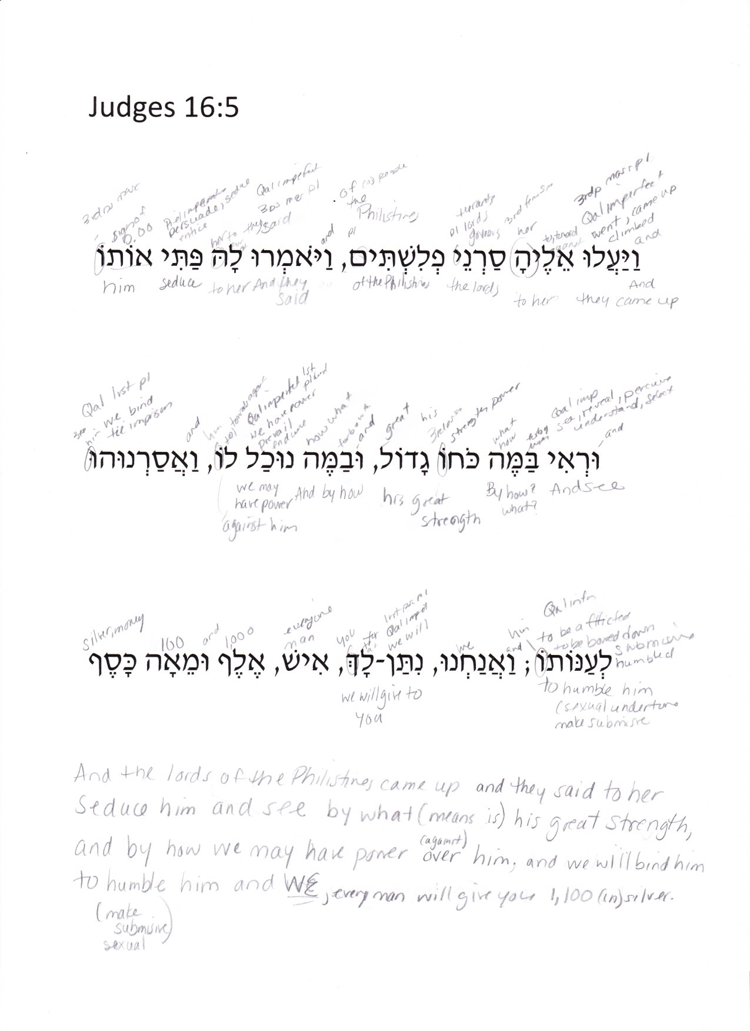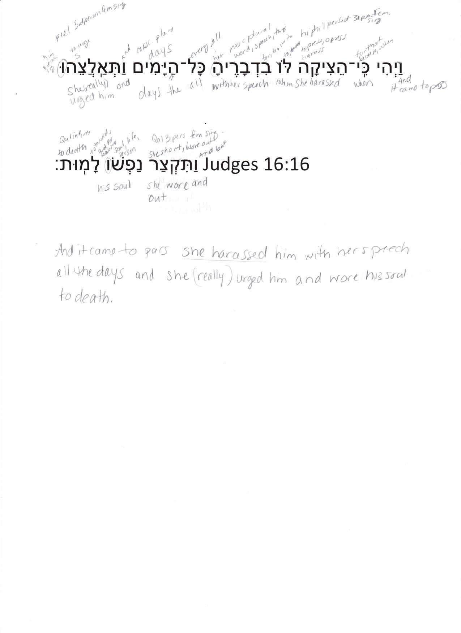
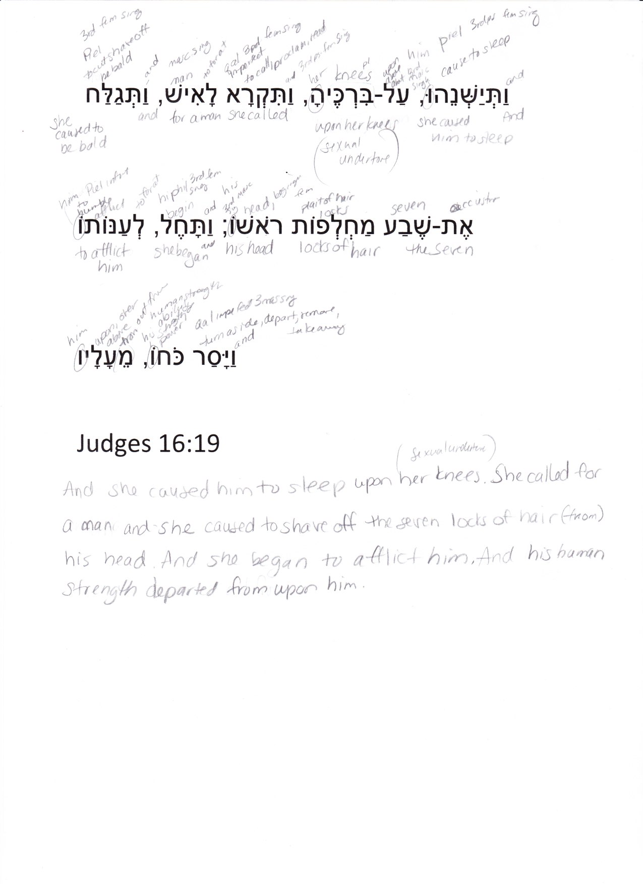

Bibliography
Alter, Robert. 1990. "Samson without Folklore." Edited by Susan Niditch. Text and Tradition (Scholars Press) 47-73.
Brock, Stephen E., Amanda Nickerson, and Michelle Serwacki,. 2013. "Youth Gun Violence Fact sheet." National Association of School Psychologist . Accessed 03 2018. http://www.nasponline.org/search/search-results?keywords=youth+gun+violence+fact+sheet.
Clemons, James T. 1990. What Does The Bible Say About Suicide? Minneapolis: Fortress Press.
M.D., Alex Lickerman. 2010. "The Six Reasons People Attempt Suicide." Psychology Today. 04 29. Accessed 04 14, 2018. https://www.psychologytoday.com/us/blog/happiness-in-world/201004/the-six-reasons-people-attempt-suicide.
M.Gunn, David. 2012. "Samson's Suicide and the Death of Three Thousand Others in Children's Bible Stories through Two Centuries." In Text, Image, and Otherness in Children's Bibles What is in the Picture?, edited by Caroline Vander Stichele and Hugh S. Pyper, 241-269. Alanta: Society of Biblical Literature.
McCann, J Clinton. 1989. Interpretations A Bible Commenary for Teaching and Preaching Judges. Louisville: John Knox Press.
McCann, J. Clinton. 2002. Judges: Interpretations A Bible Commentary for Teaching and Preaching. Louisvile: John Knox Press.
Meloy, J Reid, Jens Hoffman, Karoline Roshdi, and Angela Guldimann. 2014. "Some warning behaviors discriminate between school shooters and other students of concern." Journal Of Threat Assessment And Management 1 (3): 203-211.
Niditch, Susan. 2003. Judges A Commentary. Louisville: Westminster John Knox.
Niditch, Susan, and Jennifer K. Cox. 2008. Judges: A Commentary. Vol. Old Testament Library. Louisville: Wesminster John Knox Press.
Peterson, Jordan Dr. 2018. 12 Rules for Life. Toronto: Penguin Random House Canada.
Poling, Edward L. 1990. "Youth Suicide and the Bible." Brethren Life And Thought 35 (4): 274-290.
Sarah Knapp, Allison Marziliano, Anne Moyer. 2014. "Health Psychology Open: Identity threat and stigma in cancer patients." National Center for Biotechnology Information, U.S. National Library of Medicine. 06. Accessed 11 24, 2017. https://www.ncbi.nlm.nih.gov/pmc/articles/PMC5193175/.
Schipper, Jeremy. 2011. ""What was Samson thinking in Judges 16,17 and 16,20?."." Biblica 92 (1): 60-69.
Scholz, Susanne. 2012. "Judges." In Women's Bible Commentary, edited by Carol Newsom, Sharon Ringe and Jacqueline Lapsley, 113-127. Louisville: Westminster John Knox Press.
Shemesh, Yael. 2009. "Suicide in the Bible." Jewish Bible Quarterly 36 (3): 157-168.
Webb, Barry G. 2012. The Book of Judges. Grand Rapids: William B. Eerdmans Publishing Company.
Yandoli, Krystie Lee. 2018. ""13 Reasons Why" Is Adding A New Anti-Suicide Warning Video To Its Second Season." Buzz Feed News. March 21. Accessed March 21, 2018. https://www.buzzfeed.com/krystieyandoli/13-reasons-why-warning-video-suicide-study-netflix?utm_term=.vfV2QzNaR#.qtWd5Emv0.

Judges 6:6 NRSV All scripture quotations from NRSV unless otherwise noted.
Judges 6:3
J. Reid Meloy, Jens Hoffmann, Karoline Roshdi, and Angela Guldimann, “Some Warning Behaviors Discriminate Between School Shooters and Other Students of Concern,” Journal of Threat Assessment and Management 1, no. 3 (2014): 203-2011.
Robert Alter, “Samson without Folklore” Text and Tradition ed. by Susan Niditch (Atlanta; Scholars Press, 1990) 50.
Susanne Scholz "Judges." In Women's Bible Commentary, ed. by Carol Newsom, Sharon Ringe and Jacqueline Lapsley (Louisville: Westminster John Knox Press, 2012) 122.
Barry G. Webb The Book of Judges (Grand Rapids: William B. Eerdmans Publishing Company, 2012) 400.
Susan Niditch Judges A Commentary (Louisville: Westminster John Knox, 2003) 168.
Jeremy Schippers, "What was Samson thinking in Judges 16,17 and 16,20?" Biblica 92 (1) page 63.
Ibid, 61.
Susan NIditch Judges 166.
My translation see appendix A
Susanne Scholz, Judges, 122.
My translations see appendix A
See my translation of the verb עָנָה of Judges 16:5 found also in verses 6 and 19 in Appendix A
Susan Niditch, Judges 164,167.
Ibid, 164.
J Reid Meloy and others, Some Warning Behaviors, 204.
Dr. Jordan Peterson, 12 Rules For Life (Canada: Random House, 2018) 151.
J Reid Meloy and others, Some Warning Behaviors, 203-205.
David M. Gunn, “Samson’s Suicide And Death of Three Thousand Others in Children’s Bible Stories Through Two Centuries” Text, Image, & Otherness in Children’s Bibles ed. by Caroline Vander Stichele and Hugh S. Pyper (Atlanta: Society of Biblical Literature, 2012) 241.

